These are some examples of how geospatial mappings can be leveraged to access environmental and health challenges faced by San Diego County regions. These will be seen on the medical/developer end when users input their information. The maps will be populated and will help track areas in need of resources. The providers can hover over different areas, see the basic statistics of disease occurrences as well as user feedback, represented in the 5-point rating. User input supports AI to garner the ability to provide health plans and resources, including access to care, health management as well as education, tailored to those regions.

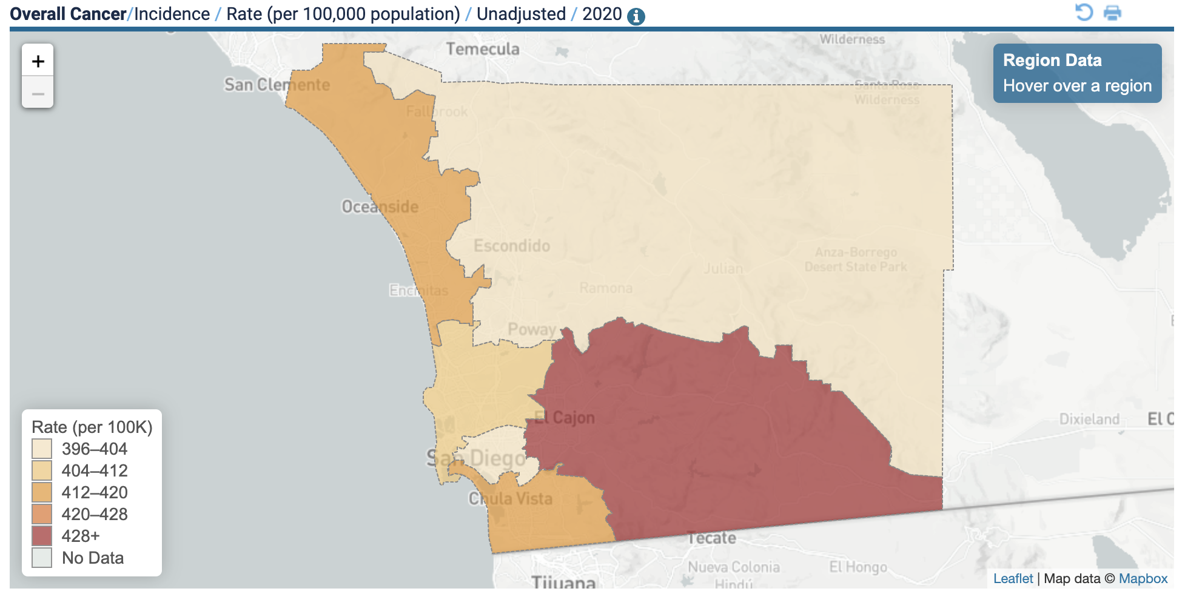

East region and South region (U.S.-Mexico border regions) have the highest number of cancer incidents.

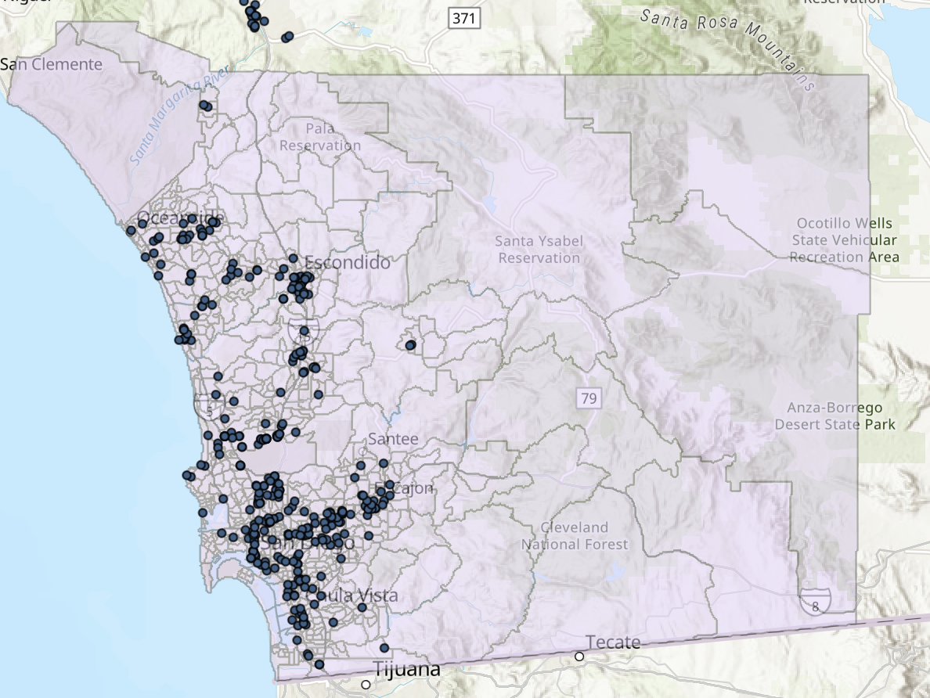

More clustering on healthcare facilities in the coastal regions

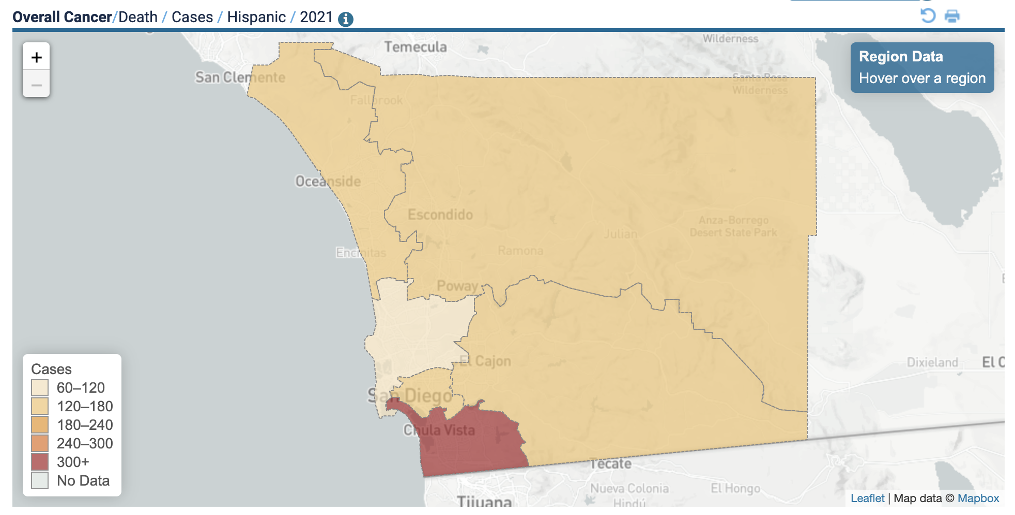

Cancer deaths in Hispanic populations are common in the South region.

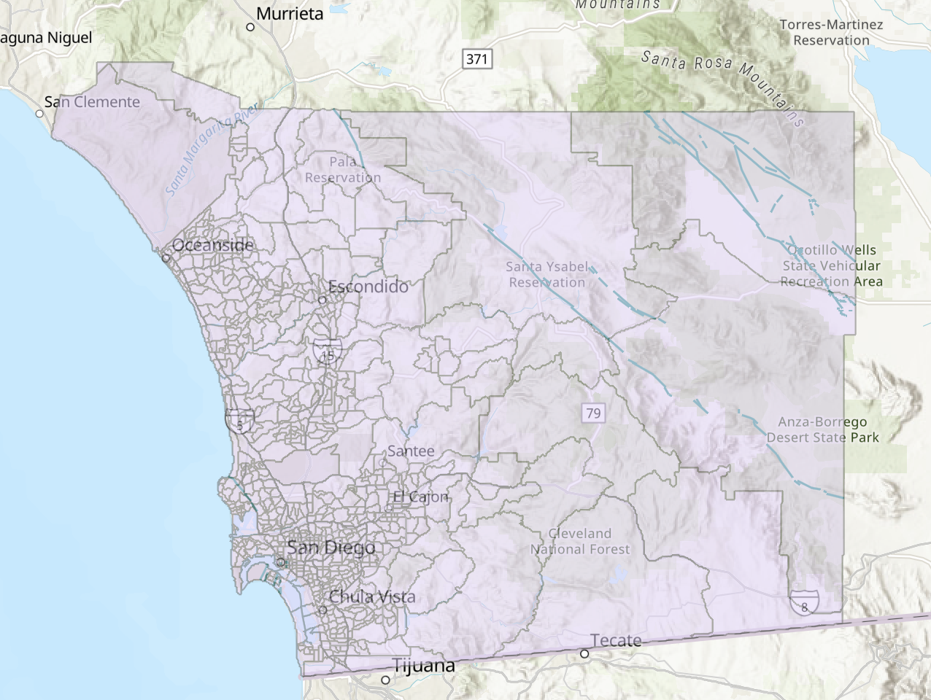

Fault Lines in San Diego County: common in North Inland region

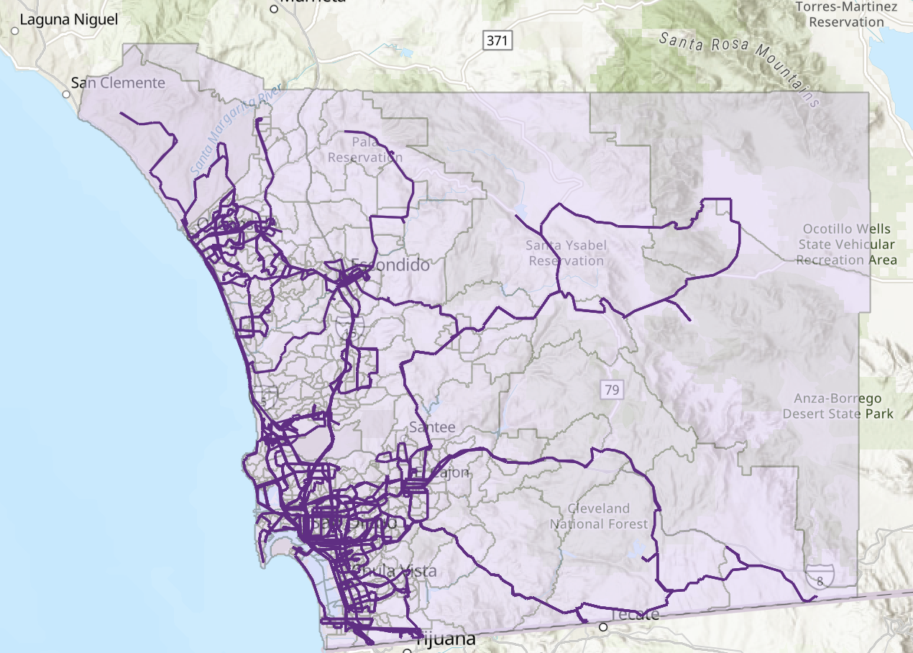

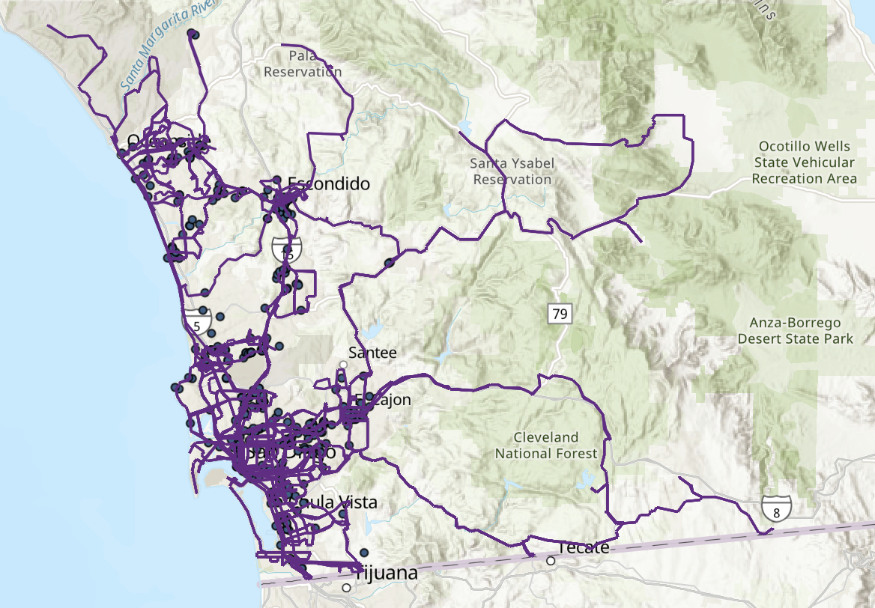

More clustered in coastal regions. Transportation assistance can be provided to meet the needs of areas that are remote. Maps, directions, and guidance (in multiple languages) are available for users to access health services locations.

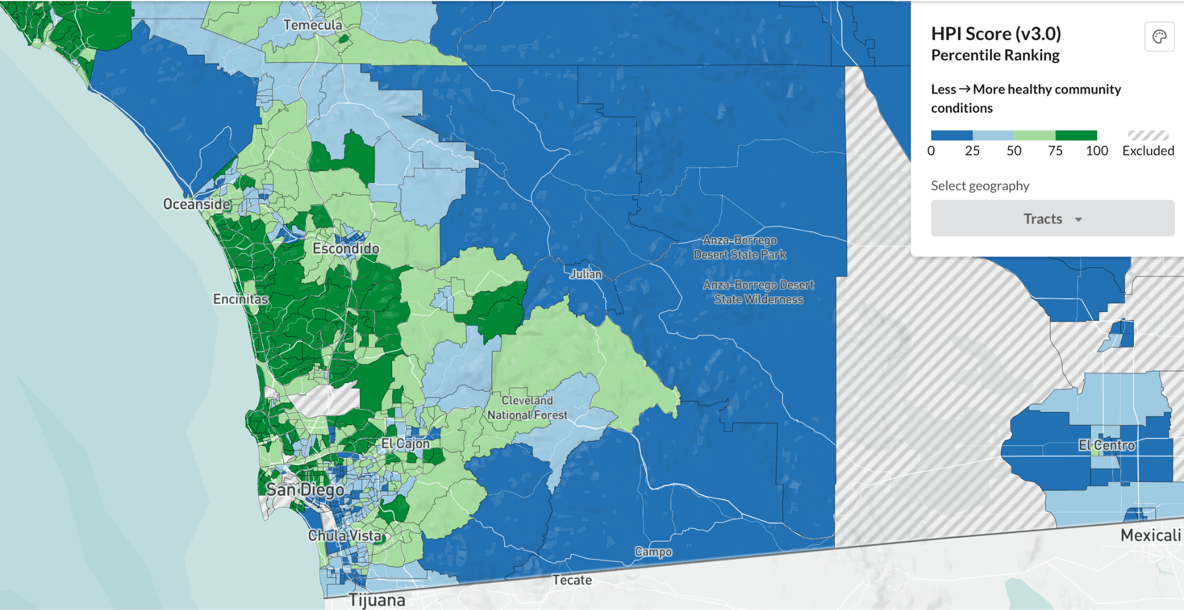

<https://map.healthyplacesindex.org/?redirect=false>

<https://geo.sandag.org/portal/apps/experiencebuilder/experience/?id=fad9e9c038c84f799b5378e4cc3ed068&page=Home#data_s=id%3AdataSource_1-0%3A242>

<https://moores.healthdat.org/diseases.php>